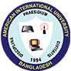

American International University -Bangladesh

Course Teacher

Md. Saif, Rumi

American International University-Bangladesh (AIUB)

Employee Management System

Version: 1.01

Submit date:

8th May, 2014

A report submitted to the Faculty of Science Department in part-fulfillment of the requirements of the course Object Oriented Programming II, spring 2014.



**Name: Employee Management System (EMS)**

Prepared & submitted by

Sharar, Shihab

12-21060-1

Sec C

**Description:**

The aim of this project is to fully automate the Employee Management System.

**Requirement:**

* Manage Employees
* Create Employee By the Admin
* generate Full database view
* Employee details
* Employee Detail Update
* Delete Employee
* Search Employee

**Features:**

**1. Main Form:**

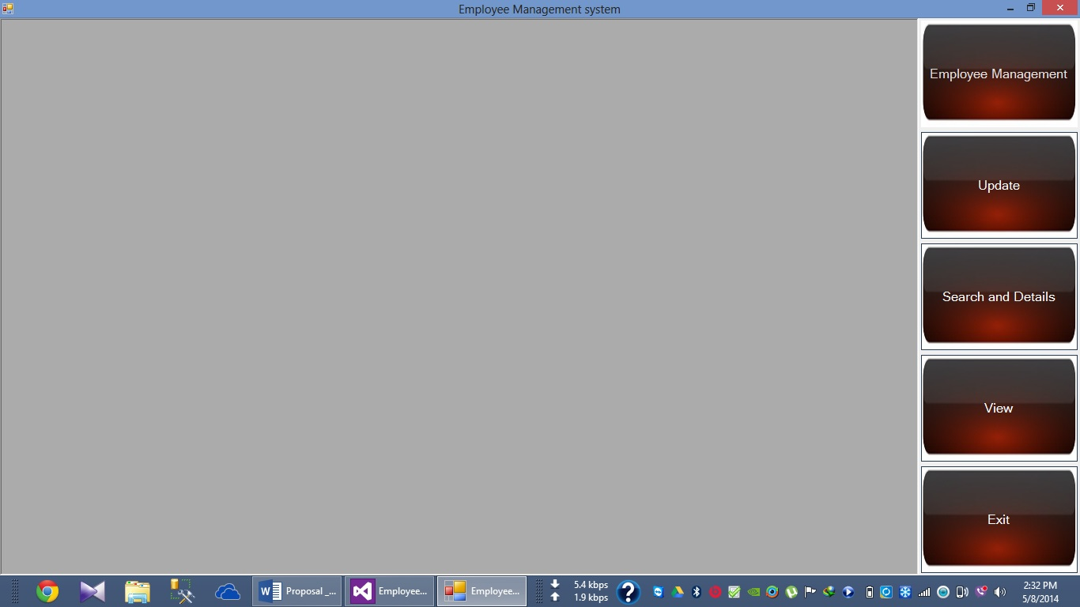

This will show you the basic features of the management system through a tool strip at the right side.

**2. Employee management system:**

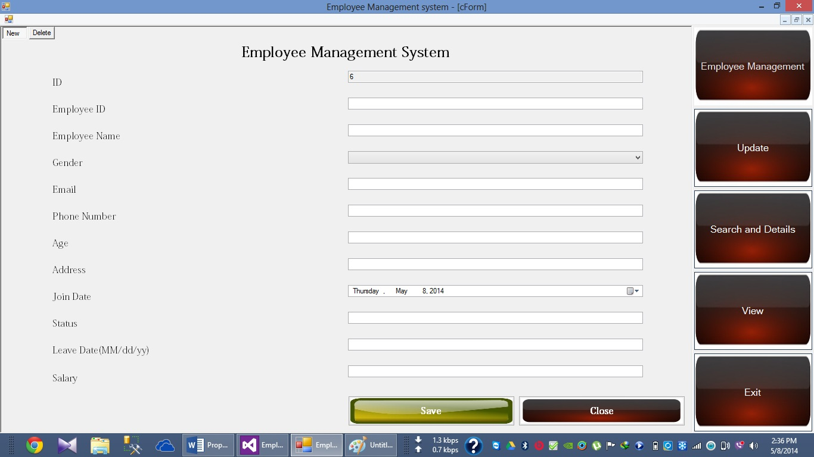

1. **New:** This feature will give the opportunity of creating an employee to the admin.
2. **Delete:** This feature will give the opportunity of deleting an Employee to the admin.

**3. Update:**

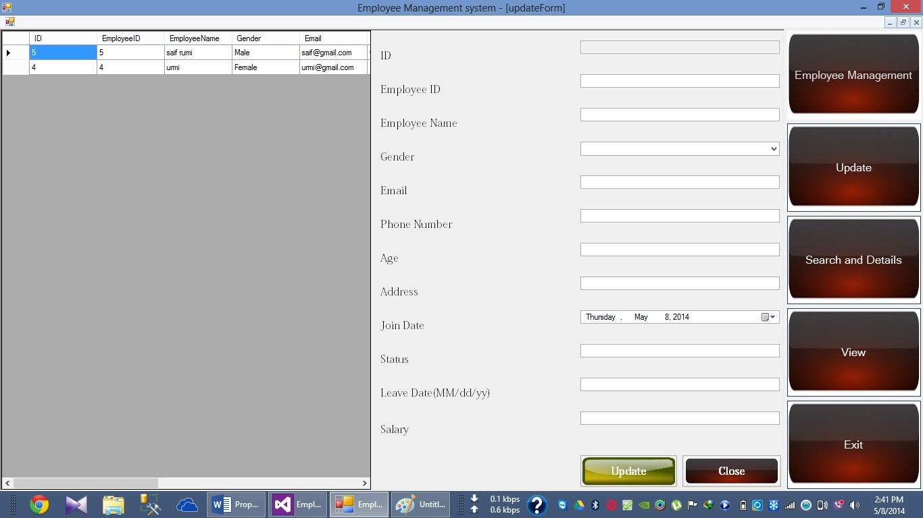

This Feature will give you the opportunity of updating the details of an employee to an admin.

**4. Search and Details:**

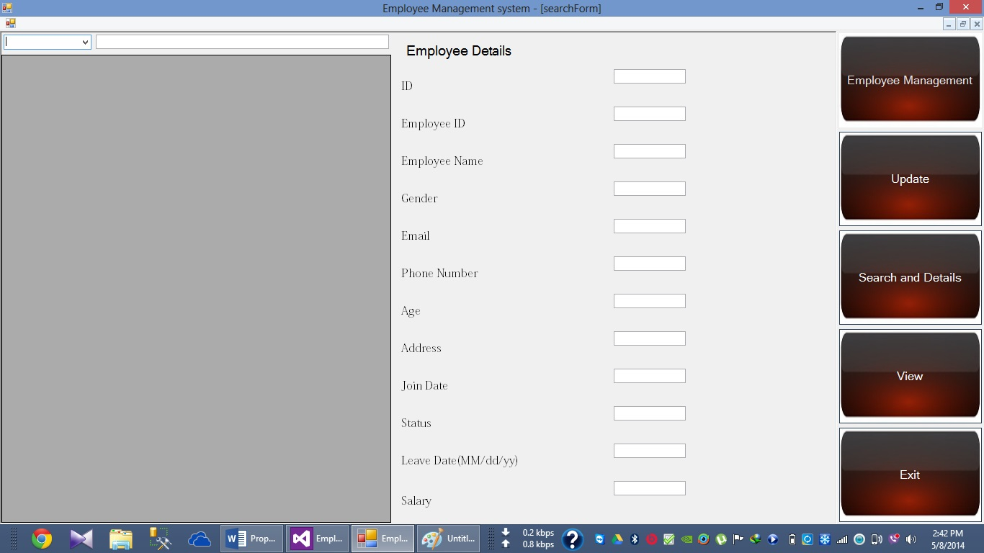

This feature will give the opportunity of searching an Employee by Employee Name and Employee ID and it will also give the opportunity of viewing the details of an employee.

**5. View:**

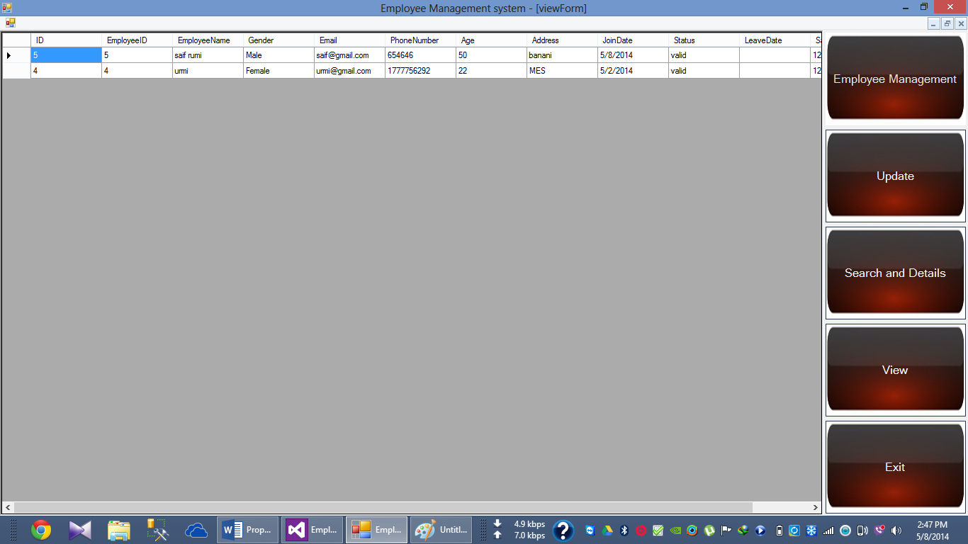

This Feature will give the opportunity of viewing the whole Database at once to the admin.